HCD6818E Compact Weather Station
（T+RH+P+WD+WDIR+Rianfall+PM2.5/10+UV）
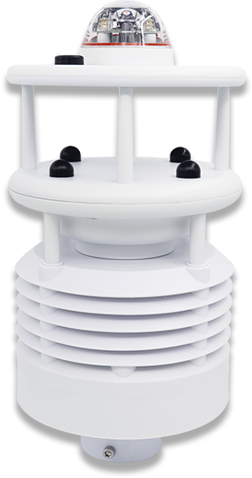

OVERVIEW
HCD6818E is designed and produced by Handan Yunnong Intelligent Agricultural Technology Co., Ltd and usded to measure various meteorological parameter for Smart environment, smart city, industrial pollution. It innovatively realizes PM2.5、PM10、UV、T、RH through a highly integrated structure, which can realize the 24-hour continuous online monitoring of outdoor meteorological parameters, and output the parameters to the EPA.In addition, it also can added to measure H₂S, volatile organic pollutants, total suspended particulate matter and other meteorological sensors (wind speed, wind direction, atmospheric pressure, rainfall, sunshine radiation)
APPLICATION
HCD6818E can be widely used in urban environmental monitoring, wind power generation, meteorological monitoring, Bridges, tunnels, ships, aviation airports, agricultural meteorology, water conservancy meteorology, power environment, highway meteorological monitoring and other fields.No maintenance and on-site calibration is required.


FEATURES

1、Standard configuration monitoring PM2.5、PM10、UV、T、RH, RS485（MODBUS ）；
2、High precision, reliable performance, suitable for outdoor weather harsh environment;
3、Parameter collection, optional wireless data collector, automatic data upload network platform, mobile phone client real-time data view；
4、Real-time monitoring of meteorological environmental data, low cost, suitable for grid distribution；
5、Small size, modular design, flexible layout；
6、Optional GPS positioning, device tracking function；
7、Data acquisition adopts 32-bit high-speed processing chip, stable and anti-interference.

Measture item | Principle | Range | Resolution | Accuracy
Atmospheric temperature | Energy gap method | -40-60℃ | 0.1℃ | ±0.3℃（25℃）
Atmospheric humidity | Capacitance method | 0-100%RH | 0.1% | ±3%RH
Atmospheric pressure | Piezoresistive | 300-1100hpa | 0.1hpa | ±0.5hpa（0-30℃）
Wind speed | Ultrasonic | 0-60m/s | 0.01m/s | （（0-30m/s）±0.3m/s or±3%
Wind direction | Ultrasonic | 0-360° | 0.1° | ±2°
Rianfall | Photology | 0-200mm/h | 0.2mm | Error<10%
PM2.5 | Laser way | 0-1000ug/m³ | 1ug/m³ | ±10%(<500μg)
PM10 | Laser way | 0-1000ug/m³ | 1ug/m³ | ±10%(<500μg)
UV | Electrochemical principle | 0-15 | 1 | 1
Option | Wind speed, wind direction, atmospheric pressure, rainfall, H2S, noise, sunshine radiation, AQI index, ultraviolet ray, noise
Supply | 12-24VDC
Output | RS485(Modbus)
fixed form | Sleeve fixed, flange fixed
Power consumption | <1w@12V
Ingress Protection | IP65
Work Environment | Temperature: -40-70℃；Humidity: 5-90%RH
Add function | ● data collector (net port, GPRS)  ● Fixed brackets (1.5m, 3m) constitute a complete set of monitoring station  ●B/S architecture software platform, mobile APP client software (android version only)  ● Solar power system
Main material | ASA+engineering plastics
Mounting frame | 1.5m, 3m Flange, 1.8m tripod
GPS | Device tracking and positioning
Data Release | PC、Telephone APP、LED、LCD TV display, etc
TECHNICAL SPECIFICATION

1.Thermometer shelter (temperature, humidity, air pressure monitoring position)
2.PM2.5、PM10、CO、NO2、SO2、O3
3.Bottom fixed with flange

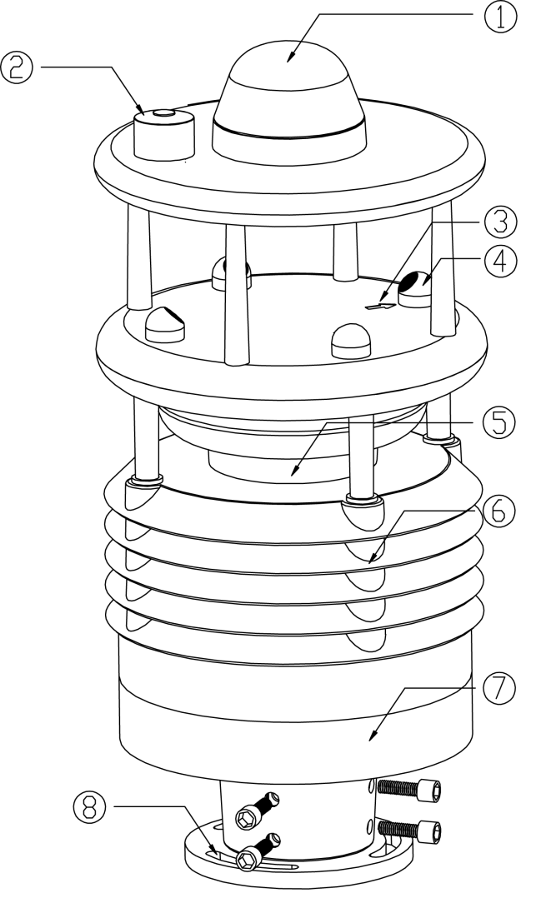

1.Rainfall sensor (optics)
2.ultraviolet ray
3.Arrows to point north
4、Ultrasonic probe
5、Control circuits
6、Thermometer shelter (temperature, humidity, air pressure monitoring position)
7、PM2.5、PM10
8. Bottom fixed with flange
※This product can be equipped with electronic compass.

MODBUS RTU COMMUNICATION PROTOCOL
Baud rate：9600
Data bits：8
Stop bit：1
Check bit：None

5.1 CRC instruction：
Among all the following instructions, the two bytes of CRC16 in MODBUS RTU protocol are as follows: the low byte comes before the high byte comes after.
In the following instructions, the sensor address 0xFF is assumed (the sensor default address is FF)

5.2 Return error code rule：
When receive error instruction (including CRC16 validation error), the sensor will not return error code. After the instruction is issued 100ms, it fails to receive issuing instruction The upper computer may consider failure and may resend the instruction.

5.3 Standard MODBUS register specification
Note: The quantity or length of register in Modbus is two bytes and 16 bits(the high byte comes first and the low byte comes last), Non - byte 8 bits are a unit.
The user shall ensure that the range of the address and the range of quantity of registers are within the system range.If it exceeded, the output of the sensor will be unpredictable. The user shall ensure that the MODBUS meets the requirements of this manual in the software design of the upper computer
Input register: read with function code 03
Address | operation | Contents | Notes
0x0001 | read-only | Noise, Hexadecimal number is magnified as 10 times, such as 0x021C indicates noise of 54.0db
0x0002 | read-only | Keep
0x0003 | read-only | SO2 concentration,hexadecimal ,such as 0x0172, indicates that SO2 concentration is 370ppb.
0x0004 | read-only | NO2 concentration,hexadecimal ,such as 0x0036, indicates that NO2 concentration is 54ppb
0x0005 | read-only | CO concentration,hexadecimal ,such as 0x0A00, indicates that CO concentration is 2560ppb
0x0006 | read-only | O3 concentration,hexadecimal ,such as 0x0123, indicates that O3 concentration is 2560ppb
0x0007 | read-only | PM2.5 concentration,hexadecimal ,such as 0x0172, indicates that PM2.5 concentration is 370ug/m³
0x0008 | read-only | PM10 concentration,hexadecimal ,such as 0x0193, indicates that PM10 concentration is 403ug/m³
0x0009 | read-only | Atmospheric temperature, Hexadecimal number plus 40 then it is magnified as 100 times, such as 0x1B00 indicates 6912/100-40=29.12℃
0x000A | read-only | Atmospheric humidity, Hexadecimal number is magnified as 100 times, such as 0x1603 indicates 5635/100=56.35%
0x000B | read-only | Atmospheric tempress, Hexadecimal number is magnified as 10 times, such as 0x2784 indicates 10116/10=1011.6hPa
0x000C | read-only | Wind speed, Hexadecimal number is magnified as 100 times, such as 0x0125 indicates 293/100=2.93m/s
0x000D | read-only | Wind direction, Hexadecimal number is magnified as 10 times, such as 0x0C14 indicates 3092/10=309.2° | North is 0 °
0x000E | read-only | Rainfall, Hexadecimal number is magnified as 10 times, such as 0x0C14 indicates 2.2mm | The default is 10 minutes of rain
0x000F | read-only | solar radiation, Hexadecimal number, such as 0x0172 indicates 370W/㎡
0x0010 | read-only | illumination, Hexadecimal number is magnified as 100 times, such as 0x0123 indicates 2.91.Klux
0x0011 | read-only | ultraviolet ray, Hexadecimal number, such as 0x05 indicates 5
0x0012 | read-only | CO2, Hexadecimal number, such as 0x01F4 indicates 500ppm
0x0013-0x001f | read-only | Keep
0x0105 | read-only | electronic compass, Hexadecimal number, such as 0x0036 indicates 54° | North is 0

Internal register: function code 03 to read; function code 06 to write.
Address | operation | Contents | Notes
0x0000 | Read and write | Sensor address, range 0x01-0xff (decimal), factory set to 0xFF

Note：The data of address indicated by hexadecimal, for example, address 20 (decimal) read and write values is 0x14

5.4 communication examples
Here is an example of using Modbus RTU command to access system registers
1.Read multiple input registers (5 live data) commands
Send：FF 03 00 09 00 05 40 15
FF | 03 | 00 09 | 00 05 | 40 15
System address | function code | Register address | Register number | CRC16 check bit generated automatically by software
Answer：FF 03 0A 1A 57 0C 5F 27 83 00 00 0C 14 36 E0
FF | 03 | 0A | 1A 57 0C 5F 27 83 00 00 0C 14 | 36 E0
System address | function code | Number of bytes of data segment | Data segment data | CRC16 check bit

parse data：
0x1A57= 0x1A * 256 + 0x57= 6743
Temperature = 6743/100-40=27.43℃
0x0C5F= 0x0C * 256 + 0x5F= 3167
Humidity=3167/100=31.67%RH
0x2783= 0x27 * 256 + 0x83= 10115
atmospheric pressure=10115/10=1011.5hPa
0x0000=0
Wind speed=0/100=0.00m/s
0x0C14=0x0C * 256 + 0x14= 3092
Wind direction=3092/10=309.2°

2.Read the single input register command
Send：FF 03 00 01 00 01 C0 14
FF | 03 | 00 01 | 00 01 | C0 14
System address | function code | Register address | Register address | CRC16 check bit generated automatically by software

Answer：FF 03 02 02 1C 91 39
FF | 03 | 02 | 02 1C | 91 39
System address | function code | Number of bytes of data segment | Data segment data | CRC16 check bit
parse data：
0x021C= 0x02 * 256 + 0x1C= 540
Noise = 540/10=54.0dB

3.Read the address register command
Send：00 03 00 00 00 01 85 DB
00 | 03 | 00 00 | 00 01 | 85 DB
 | function code | Register address | Register address | CRC16 check bit generated automatically by software

Answer：00 03 02 00 01 44 44
00 | 03 | 02 | 00 01 | 44 44
 | function code | Number of bytes of data segment | Data segment data | CRC16 check bit
Data segment data0x0001 =01 system address 01

4、Modify internal register（System address）Command（Modify address to 0x33）
Send：00 06 00 00 00 33 C8 0E
00 | 06 | 00 00 | 00 33 | C8 0E
 | function code | Register address | New address | CRC16 check bit

Answer：00 06 00 00 00 33 C8 0E （Indicates successful modification）
00 | 06 | 00 00 | 00 33 | C8 0E
 | function code | Start address | New address | CRC16 check bit
5、 Read the electronic compass (output value is the Angle between compass north and sensor north arrow)
Send：FF 03 01 05 00 01 80 29
FF | 03 | 01 05 | 00 01 | 80 29
Station number | function code | Register address | Register number | CRC16 check bit
Answer：FF 03 02 00 36 11 86
FF | 03 | 02 | 00 36 | 11 86
Station number | function code | Number of bytes of data segment | Data segment data | CRC16 check bit
6、Set time of rainfall accumulation
Send：00 06 01 04 00 0A 48 21
00 | 06 | 01 04 | 00 0A | 48 21
 | function code | Start address | Time accumulation(min) | CRC16 check bit

Answer：00 06 01 04 00 0A 48 21 （Indicates successful modification)
00 | 06 | 01 04 | 00 0A | 48 21
 | function code | Start address | accumulation(min | CRC16 check bit

Note：The default immediate time is 10 mins from factury
When the cumulative time of rainfall is set to 0, the equipment does not automatically reset , but accumulates all the time. The rainfall can be reset by resetting the cumulative time of rainfall after power failure
After done sets restart the prodcuts
7、Set the declination correction（Only for the selection of electronic compass）
Send：00 06 01 03 00 05 B9 E4
00 | 06 | 01 04 | 00 05 | B9 E4
 | function code | Register address | correction angle | CRC16 check bit

Answer：00 06 01 03 00 05 B9 E4 （Indicates successful modification）
00 | 06 | 01 03 | 00 05 | B9 E4
 | function code | Start address | correction angle | CRC16 check bit

Correction Angle
The high octet represents the correction direction, 0x00 represents a positive correction, and 0x01 represents a negative correction
The lower eight are the angles that need to be corrected
Such as 0x00 05 Indicate to need to increase the output by 5 degrees
0x01 03 Indicates to need to reduce the output by 3 degrees

8、GPRSSet up network information (for the selection of GPRS)
Set up IP AT+GPRSIP=xxx.xxx.xxx.xxx#
Setport AT+GPRSPORT=xxxxx#
Save and effect the Settings AT+GPRSRESET
Read IP、Port RD+GPRSADD=
9、Read the latitude and longitude information
Send AT+GPS#
Answer GPS:36.12345,N;114.12345,E#
5.5 Else
customized according to user requirement, specific requirements can consult the relevant sales.

